This activity is graded.
Career Exploration Digital Module:
- Go to https://app.pwcfdnearnyourfuture.org/auth/login
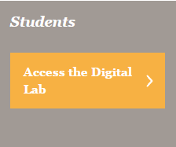
- Click:

- Username:

Password: bryanmiddle

- When prompted, change your password to your student number

- Click on Level 2

- Scroll down and click on Module 7 #Link2YourFuture

- Complete challenges and earn your badge. You must answer correctly to earn your badge.

