This activity is graded.
Career Exploration Digital Module:
- Go to https://app.pwcfdnearnyourfuture.org
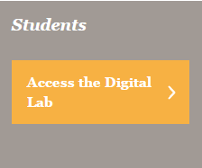
- Click:

- Username:

Password: bryanmiddle

- Reset password – enter your lunch number in both spaces

- Click on Level 2

- Scroll down and click on Module 3 Can I Afford a Phone?
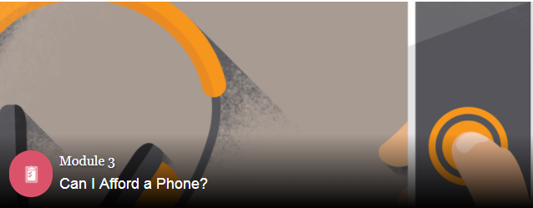

- Complete challenges and earn your badge. You must answer correctly to earn your badge.

